Dataset Name – “German Credit Card”

Summary
In this predictive analysis, we have analyzed the “Credit Card” data of German customers and recommending the credit rating of customers to the bank managers to help them making precise loan approval decisions. Here, we will be using Weka tool for data pre-processing, attribute selection, cross-validation & classification model implementation. Please follow this document to find this Predictive data analysis step-by-step.

Data Preparation
- Visualize and understand the dataset: Let us load “German Credit Card” dataset and see how Weka describes it:
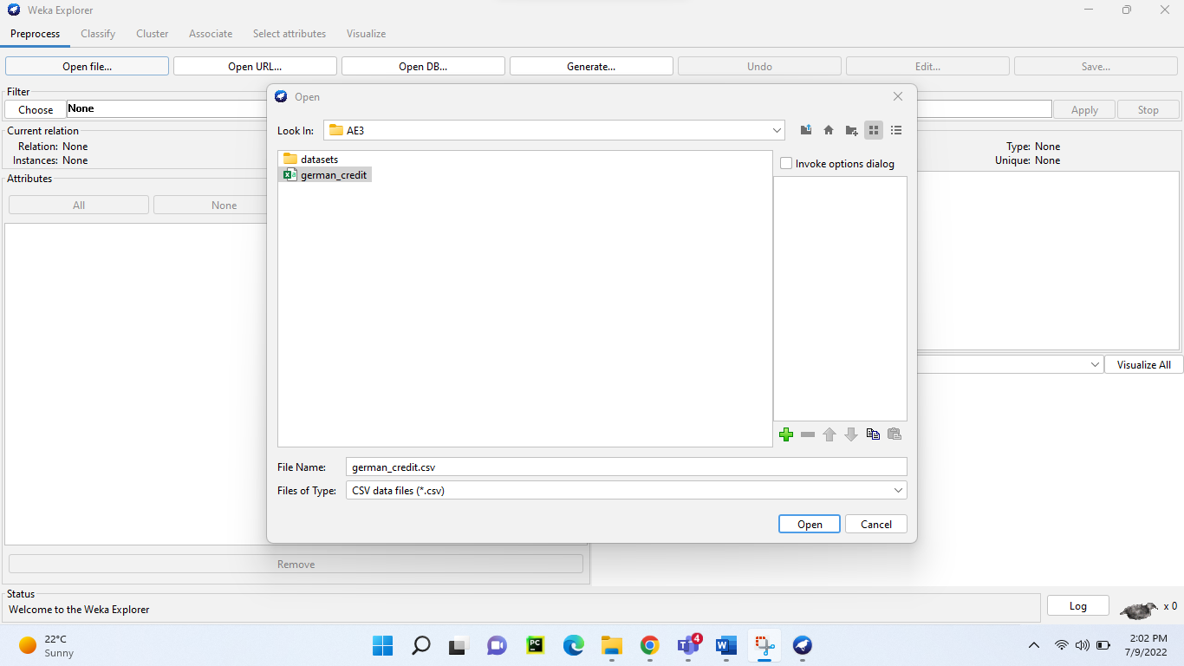
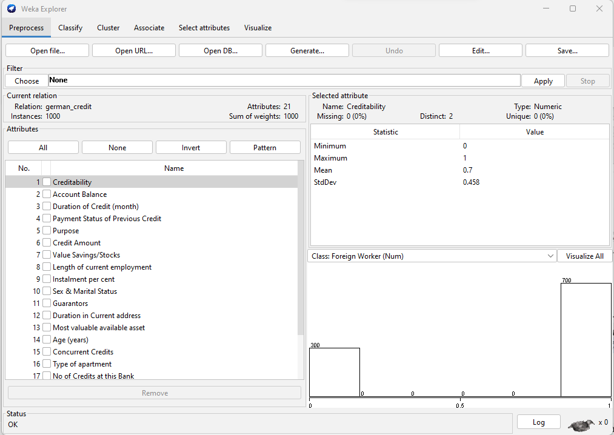
Above screen provides meta-info about the loaded dataset, like:
- name of dataset (Relation: german_credit)
- number of records it has (instance: 1000)
- number of attributes it has (Attributes: 21) and consolidated list of those attributes.
If we select any one from the Attributes list, then on the right-hand section we get the statistics of that attribute like variance and central tendencies parameters as:
- min-max, mean, standard-deviation
- missing, distinct, and unique values

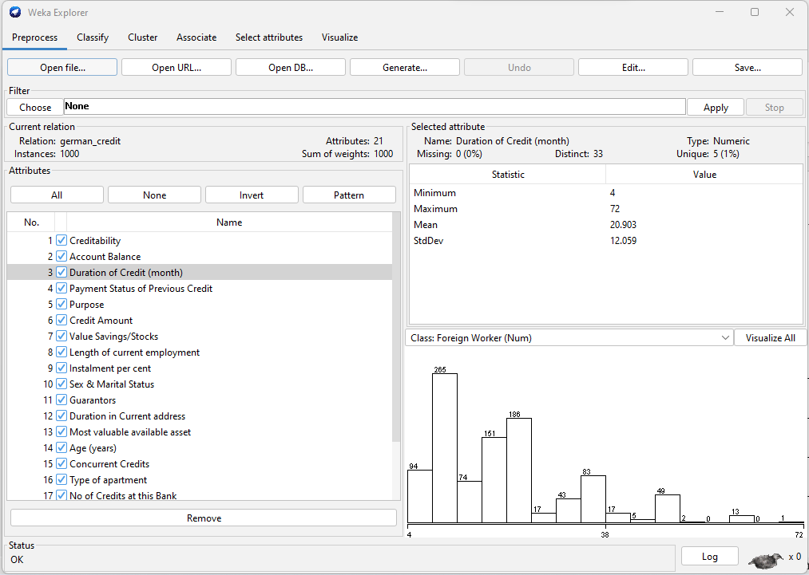

In the above figure, we can say like data type of “Duration of Credit (month)” attribute is numeric, with 0 missing and 33 distinct values. Min-max range is 4 to 72 with mean of 20.9 & standard deviation of 12.05.
We can also visualize this attribute using the histogram in the right hand bottom sub-section and say that this data is not normally distributed.
Using “visualize all”, we can see the visual representation of each-n-every attribute in single graph as below:
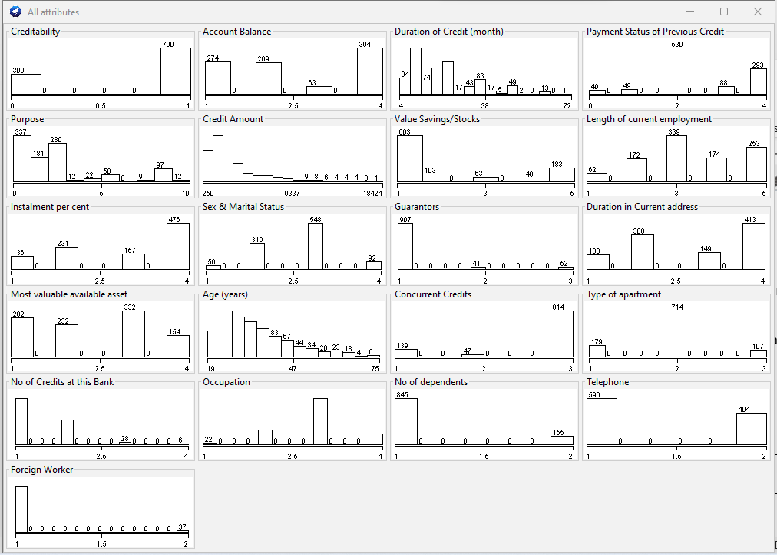

- Attributes and their data type: As already said in section 1 above, we can read about each attribute via clicking on it and see its statistical information as shown below (highlighted in yellow):
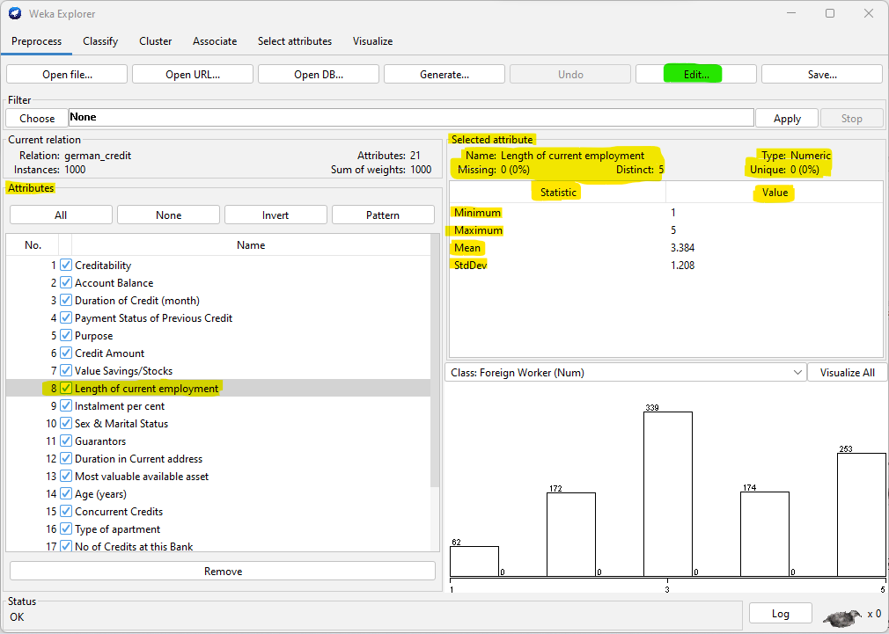
On clicking “Edit” button (highlighted in green), we can access the given dataset to make some modification/imputation if required as shown below:
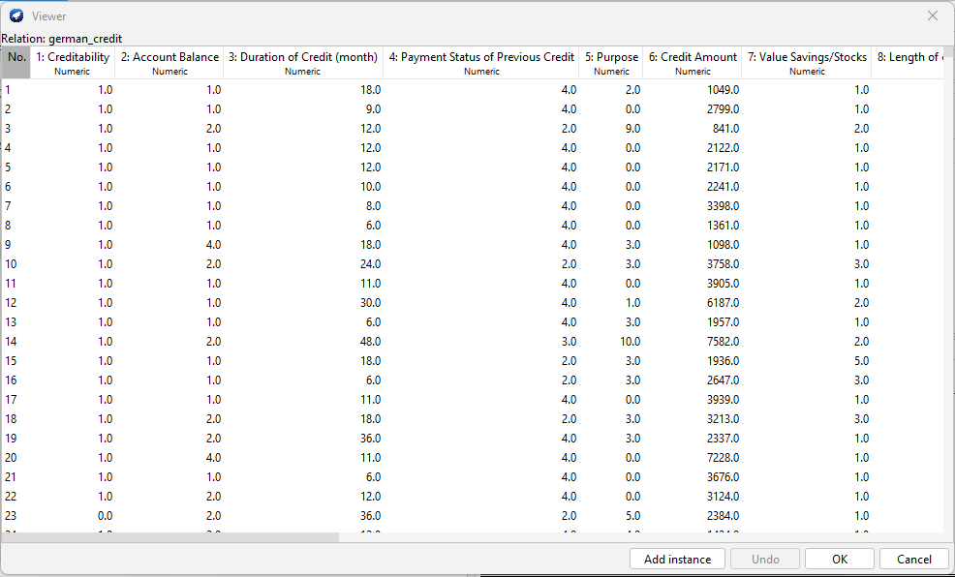
But in our case, given dataset is not having any missing/null/blank values and in fact it has already transformed categorical variable into numerical form, and hence we are seeing data type of every categorical attribute as Numeric here. We below types of variables in the given dataset, in Creditability is our target variable:
Categorical Attributes:
Creditability (Target Variable), Account Balance, Payment Status of Previous Credit, Purpose, Value Savings/Stocks, Length of current employment, Sex & Marital Status, Guarantors, Duration in Current address, Most valuable available asset, Concurrent Credits, Type of apartment, Occupation, Foreign Worker.
Numerical Attributes:
Duration of Credit (month), Credit Amount, Instalment per cent, Age (years), No of Credits at this Bank, No of dependents, Telephone.

- Which attributes are linked to the class attribute? Which ones can be eliminated?
To find a credit score, there are certain attributes which can be eliminated like “Telephone” & “Foreign Worker”. Hence, we will remove these 2 attributes.
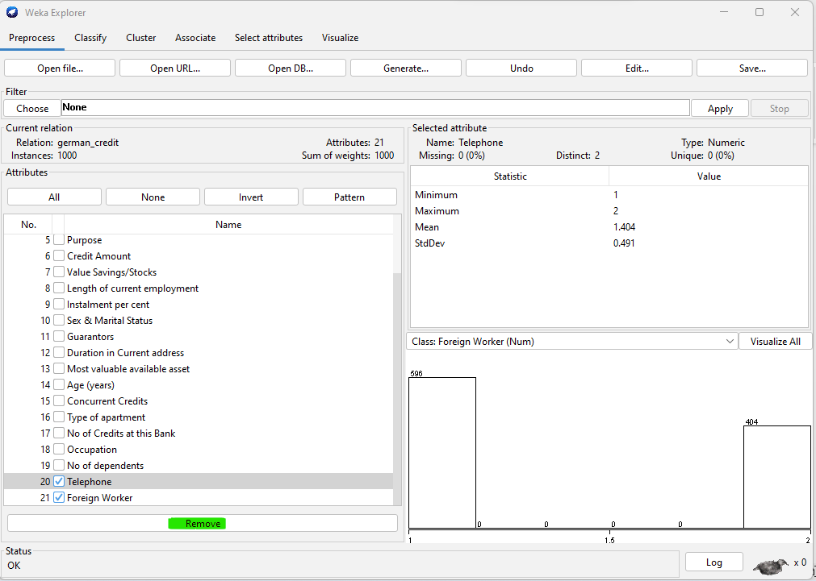
Rest of the others attributes are linked to class attribute, because in some or other way those all helps to evaluate the Loan Eligibility:
Attribute Name | Data Type
Account Balance, Payment Status of Previous Credit, Purpose, Value Savings/Stocks, Length of current employment, Sex & Marital Status, Guarantors, Duration in Current address, Most valuable available asset, Concurrent Credits, Type of apartment, Occupation | Categorical
Duration of Credit (month), Credit Amount, Instalment per cent, Age (years), No of Credits at this Bank, No of dependents | Numerical

- Missing values? Do you need to transform any attribute? (Weka filters option): In this dataset, we don’t have any missing value and all the categorical data is already transformed into numeric form. In fact, in case required we can discretize these already converted Categorical variable into Nominal data type using Discretize Weka filter as shown below:
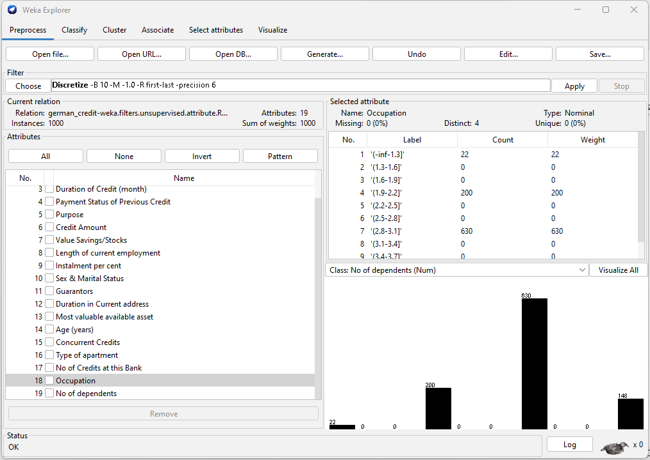
After the discretizing, we can see that these selected attribute type is changed to Nominal type alongwith showing how many distinct values that attribute is having. As per above figure, we have 4 distinct values for Occupation. Label are system generated, so we can ignore that, but just to cross check with given dataset labels for Occupation, we have 4 possible values as:
1: unemployed/ unskilled - non-resident,
2: unskilled - resident,
3: skilled employee / official,
4: management/ self-employed/highly qualified employee/ officer

- Imbalanced Class: There are certain nominal/categorical attributes which shows imbalanced distribution of classes, which can be clearly seen in the below diagram:
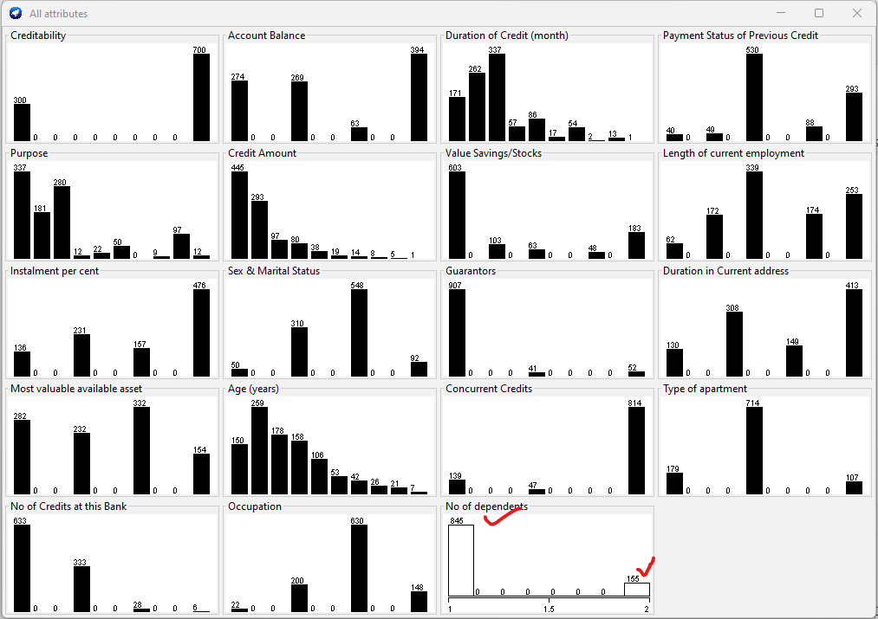
After applying ClassBalancer filter, we can see below imbalanced attribute “No.of dependents” has been balanced out:
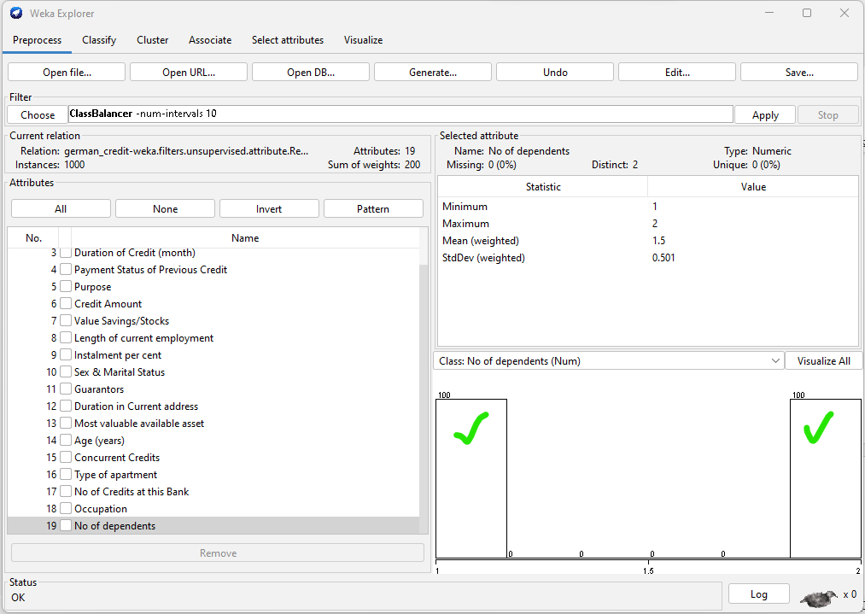
We are done with pre-processing now, Let’s apply various classification model and see the results.

Predictive Modeling/Classification

Classification Algorithms (with Cross Validation 10-Fold):
- Decision Tress: We applied the decision tree model (J48) and result depicts that 70% of instances are correctly classified with Relative Absolute Error as 94.3%:
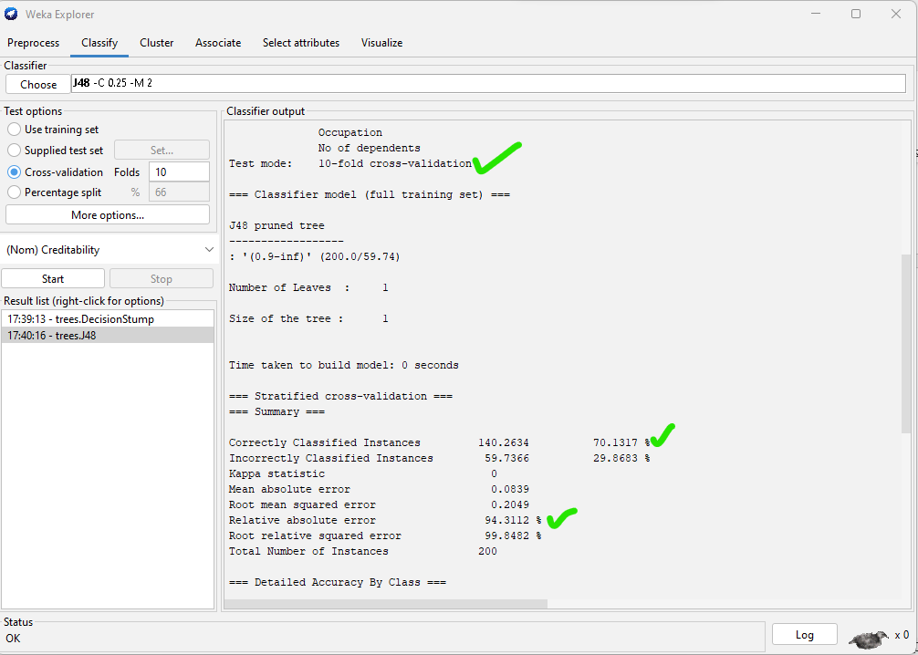
Confusion matrix: There are 140.26 instances of True-Positive & 59.74 of false positive as per the below matrix:
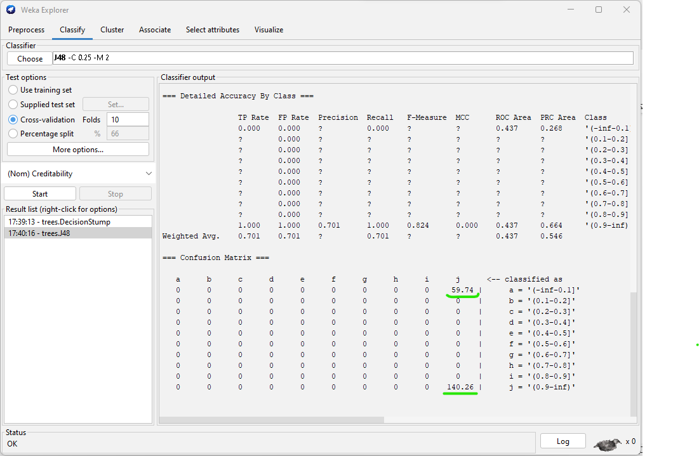
- Naïve Bayes: Accuracy observed with this algorithm is 73.6% with lesser incorrectly classified instances compared to Decision Tree, as shown below:
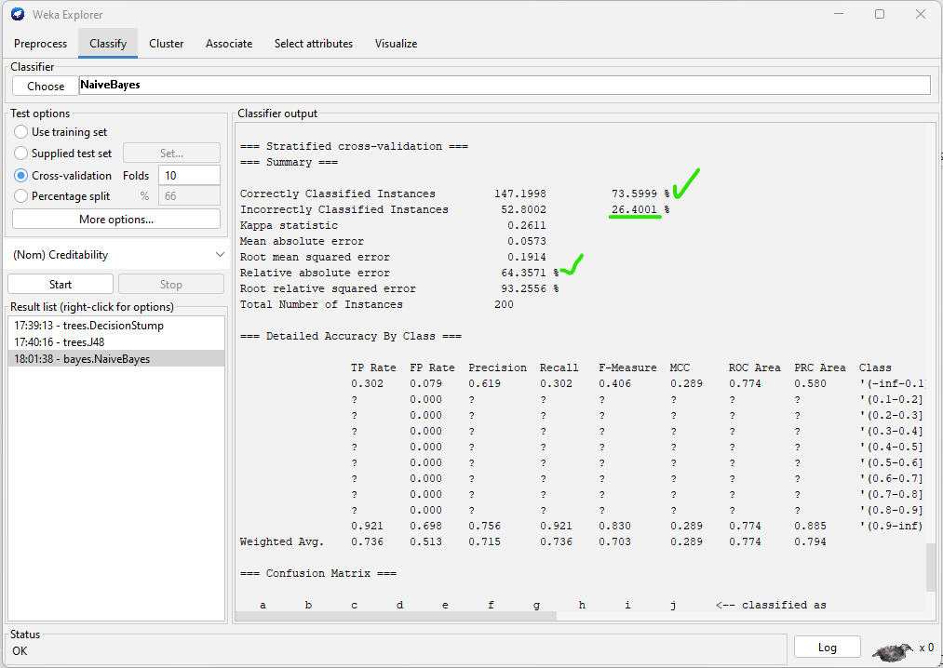
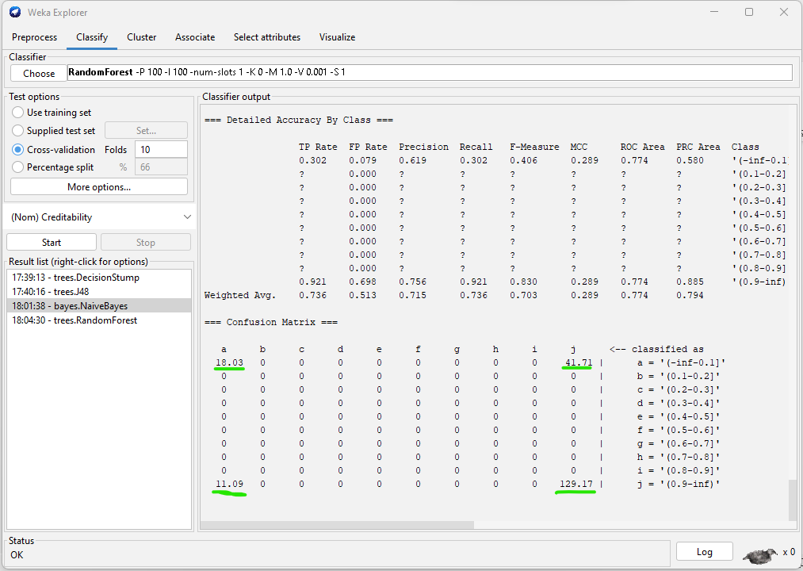
- Random Forest: Comparative to above model, Random Forest seems more suitable as per below results:
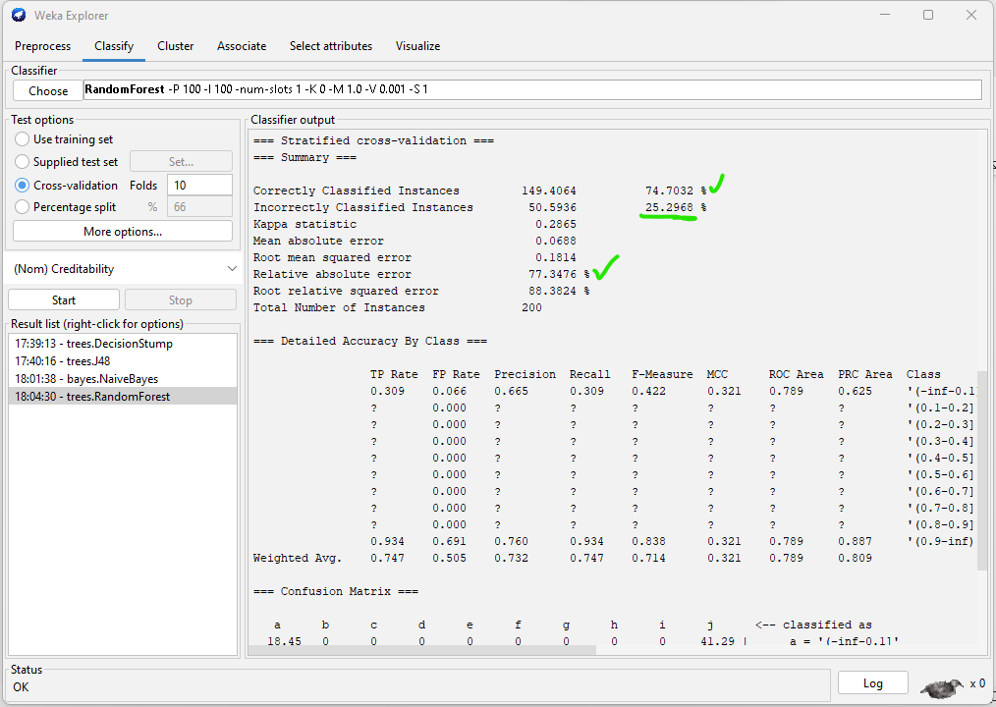
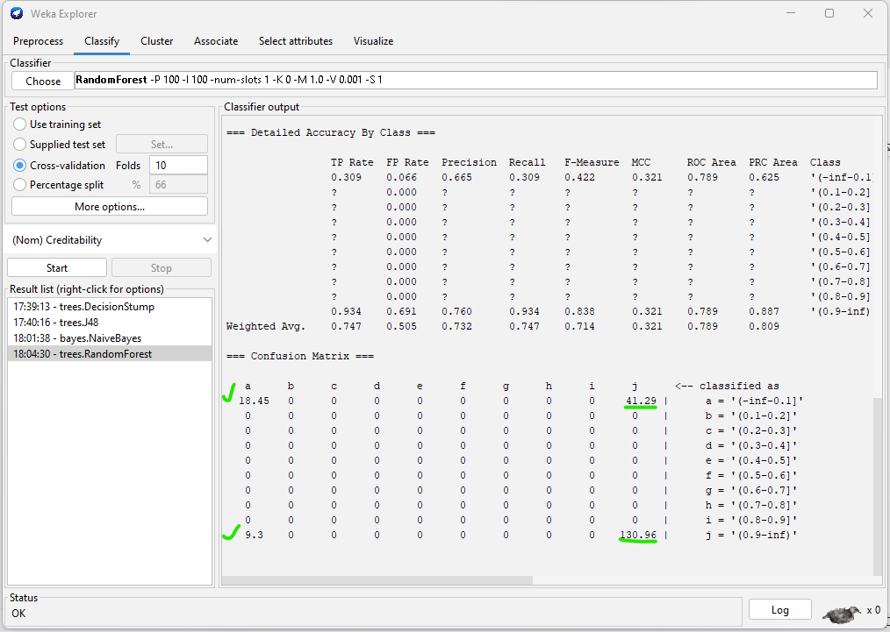
Attribute Selection: We can also select limited attributes, so that models can perform better. After doing attribute selection based on best first strategy. There are lot more other strategies like PrincipalComponent and all, but let’s see how attribute selection reduced the variables:
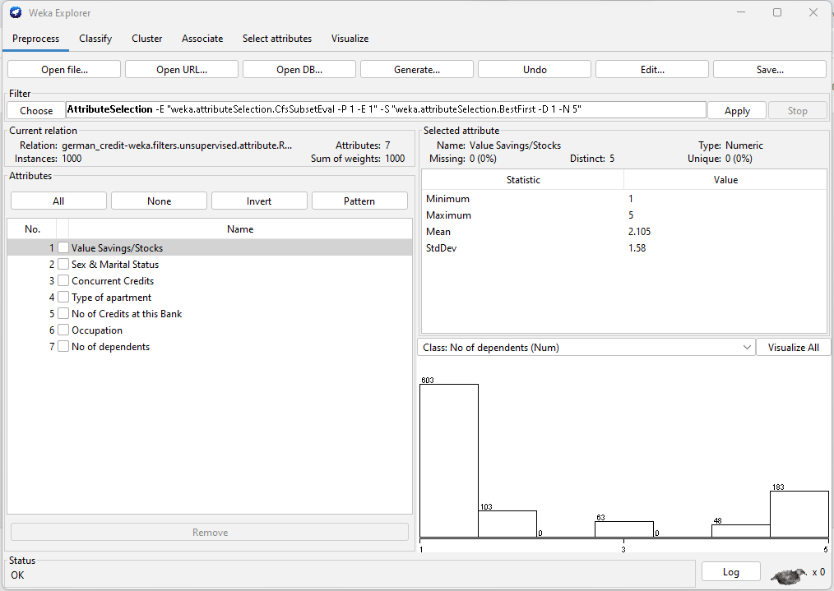
Classification Results
Based on the above confusion matrix for all the 3 classifiers, Random Forest seems to be best performing in this case with accuracy of 74.7%, whereas Decision Tree classifier has 70% and Naïve Bayes has 73.6%.

Conclusions and Recommendations

For the given German Credit Card data, Random Forest classifier seems to be good fit with Precision of 66.5%, recall of 30.9% and accuracy of 74.7%. And as per the attribute selection strategy, below variables seems to be highly affecting towards Target variable – Creditability:
Value Savings/Stocks, Sex & Marital Status, Concurrent Credits, Type of apartment, No of Credits at this Bank, Occupation, & No of dependents.
Hence, Bank manager can primarily focus over these attributes for future application and take the decisions more confidently.

